BITCOIN PRICE PREDICTION USING MACHINE LEARNING
A Major Project Report Submitted
In partial fulfillment of the requirements for the award of the degree of

Bachelor of Technology in
Computer Science and Engineering by
Sri Charan Rao 19N31A05H2

Under the esteemed guidance of Mrs.G.Shamini Assistant Professor

Department of Computer Science and Engineering Malla Reddy College of Engineering & Technology (Autonomous Institution- UGC, Govt. of India)
(Affiliated to JNTUH, Hyderabad, Approved by AICTE, NBA &NAAC with ‘A’ Grade)
Maisammaguda, Kompally, Dhulapally, Secunderabad – 500100 website: www.mrcet.ac.in

2019-2023


Malla Reddy College of Engineering & Technology
(Autonomous Institution- UGC, Govt. of India)
(Affiliated to JNTUH, Hyderabad, Approved by AICTE, NBA &NAAC with ‘A’ Grade)
Maisammaguda, Kompally, Dhulapally, Secunderabad – 500100 website: www.mrcet.ac.in

CERTIFICATE

This is to certify that this is the bonafide record of the project entitled “Bitcoin Price Prediction using Machine Learning”, submitted by Sri Charan Rao (19N31A05H2) of B.Tech in the partial fulfillment of the requirements for the degree of Bachelor of Technology in Computer Science and Engineering, Department of CSE during the year 2022-2023. The results embodied in this project report have not been submitted to any other university or institute for the award of any degree or diploma.

Internal Guide Head of the Department Mrs. G.Shamini Dr. S. Shanthi
Assistant Professor Professor

External Examiner

DECLARATION

We hereby declare that the project titled “Bitcoin Price Prediction using Machine Learning” submitted to Malla Reddy College of Engineering and Technology (UGC Autonomous), affiliated to Jawaharlal Nehru Technological University Hyderabad (JNTUH) for the award of the degree of Bachelor of Technology in Computer Science and Engineering is a result of original research carried-out in this thesis. It is further declared that the project report or any part thereof has not been previously submitted to any University or Institute for the award of degree or diploma.

Name of Students:

Sri Charan Rao 19N31A05H2

Degree : Bachelor of Technology in Computer Science & Engineering

Department : Computer Science and Engineering

Title of the project : Bitcoin Price Prediction using Machine Learning

ACKNOWLEDGEMENT

We feel ourselves honored and privileged to place our warm salutation to our college Malla Reddy College of Engineering and Technology (UGC-Autonomous) and our Director Dr.V.S.K Reddy and our Principal Dr.S.Srinivasa Rao, who gave us the opportunity to have experience in engineering and profound technical knowledge.
We express our heartiest thanks to our Head of the Department Dr. S.Shanthi for encouraging us in every aspect of our project and helping us realize our full potential.
We would like to thank our internal guide and Project Coordinator Sandeep Agarwalla for his regular guidance and constant encouragement. We are extremely grateful to her valuable suggestions and unflinching co-operation throughout project work.
We would like to thank our class in charge Dr. MS. Gorantla Shamini who in spite of being busy with her duties took time to guide and keep us on the correct path.
We would also like to thank all the supporting staff of the Department of CSE and all other departments who have been helpful directly or indirectly in making our project a success.
We are extremely grateful to our parents for their blessings and prayers for the completion of our project that gave us strength to do our project.

With regards and gratitude

Sri Charan Rao - 19N31A05H2

ABSTRACT

Bitcoin is considered the most valuable currency in the world. Besides being highly valuable, its value has also experienced a steep increase, from around 1 dollar in 2010 to around 18000 in 2017. Then, in recent years, it has attracted considerable attention in a diverse set of fields, including economics and computer science. The former mainly focuses on studying how it affects the market, determining reasons behinds its price fluctuations, and predicting its future prices. The latter mainly focuses on its vulnerabilities, scalability, and other techno-crypto economic issues. Here, we aim at revealing the usefulness of traditional auto regressive integrative moving average (ARIMA) model in predicting the future value of bitcoin by analyzing the price time series in a 3-years-long time period. On the one hand, our empirical studies reveal that this simple scheme is efficient in sub-periods in which the behavior of the time-series is almost unchanged, especially when it is used for short-term prediction, e.g. 1-day. On the other hand, when we try to train the ARIMA model to a 3-years-long period, during which the bitcoin price has experienced different behaviors, or when we try to use it for a long-term prediction, we observe that it introduces large prediction errors. Especially, the ARIMA model is unable to capture the sharp fluctuations in the price, e.g., the volatility at the end of 2017. Then, it calls for more features to be extracted and used along with the price for a more accurate prediction of the price. We have further investigated the bitcoin price prediction using an ARIMA model, trained over a large dataset, and a limited test window of the bitcoin price, with length w, as inputs. Our study sheds lights on the interaction of the prediction accuracy, choice of (p; q; d), and window size w.

.

TABLE OF CONTENTS

S.NO | TITLE | PG.NO
1 | INTRODUCTION | 07
2 | LITERATURE SURVEY | 09
3 | SYSTEM ANALYSIS  - HARDWARE AND SOFTWARE REQUIREMENTS  - SOFTWAREREQUIREMENTS SPECIFICATIONS | 11
4 | DOMAIN ANALYSIS | 12
5 | EXISTING AND PROPOSED SYSTEM  - EXISTING SYSTEM  - PROPOSED SYSTEM | 17
6 | MODULES DESCRIPTION | 19
7 | UML DIAGRAMS  - USE CASE DIAGRAM  - SEQUENCE DIAGRAM  - ACTIVITY DIAGRAM  - CLASS DIAGRAM  - DEPLOYMENTDIAGRAM | 22
8 | CONCLUSION | 28
9 | REFERENCES | 29

1.INTRODUCTION

Bitcoin is a cryptocurrency which is developed as a decentralized, peer-to-peer payment system to encourage safer online transactions without the need of a third party. The transactions, issuing and storing is independent of any central bank or server as it is based on a public distributive network known as blockchain. It utilizes cryptographic techniques and depends on an open-source algorithm which checks decentralized exchanges and controls the formation of new Bitcoin.

Regardless of the substantial vacillations of Bitcoin prices (particularly during 2013 and late 2017) and the massive growth in the capitalization of the related market, the condemnations about illicit uses and social concerns, it has still managed to draw the attention of many investors, such as China who is buying Bitcoin, seeing this as an opportunity of investments, as well as researchers in the scientific community to study and understand the market in order to predict the worth of Bitcoin. Most importantly, for the huge popularity of bitcoin, the end of the year 2017 has been the time when the price has increased most noticeably which was worth to 1600 US dollar for 1 bitcoin. Therefore, the analysis of financial data for predicting the future bitcoin price has always been an important field of research with a direct and indirect effect on world economy. In this paper, we have used time series analysis in order to find out the pattern of bitcoin price movement and forecasting the closing price of the next few days as well as analyzing the performance of the time series models.

Cryptocurrency, a technology supported virtual currency, is not issued by Government agency. It has highly volatile market price. The market capitalization of publicly traded cryptocurrencies is currently above $230 billion. The digital currency came to existence with the introduction of Bitcoin in 2013. The cryptocurrency is not regulated by government agency. Peer-to-peer network of individuals process the transactions using internet. A block chain controls digital transactions. Ethereum has the second-highest market capitalization and supports much more functionality than Bitcoin. The Cryptocurrency market works like a stock market. Effective prediction of time series using conventional and various emerging techniques like machine learning enabled the market participants to earn promising rewards from stock markets. Application of such techniques to the market of Cryptocurrencies can help the investors to take advantage of liquidity of the system and thus gain substantial profit. Cryptocurrency market is also highly volatile and hence provides room for effective prediction. Traditional time series prediction assumes linearity of data and is to be segregated into trend and seasonal componessnts. The cryptocurrencies are highly volatile and lack seasonality. Hence traditional time series models will not give smart predictions in the world of digital currencies. As the task is complex, deep learning provides an interesting tool for the

purpose.

Traditionally the richest people in a society have an average age of more than 60 years . The exponential rise in the information and communications technology (ICT) have not only changed many of our beliefs, habits and traditions, but also it has introduced a new wave of young billionaires. By introduction of bitcoin in 2009 with an initial value of around one dollar, no one predicts that in 8 yearsit will pass all previous records, and will reach to the unbelievable value of 18000 dollars. Due to such a rapid increase in the price of bitcoin and its following price correction, i.e. fall down of the price after the big jump, many economists and computer scientists tried to explore the time series of the bitcoin price . Our focus in this letter is to investigate application of the traditional autoregressive integrative moving average (ARIMA) model in prediction of bitcoin price. ARIMA has been used extensively in prediction of stationary datasets in the literature, e.g., refer to and its references.

Application of ARIMA in prediction of bitcoin price has been recently investigated in , and it has been shown that a Recurrent Neural Network model (RNN), augmented by additional data like Tweeter‘s hashtags can significantly outperform the performance, especially in long-term predictions. The interesting discovery of consists in the fact that in short time periods, ARIMA outperforms RNN, which both work on a single input, i.e., the price of bitcoin. Regarding the computational complexity associated with the neural networks, and the explain ability of results achieved by using ARIMA models, here we aim at further investigation of prediction of bitcoin price using ARIMA model for 1-day prediction of the bitcoin price. More specifically, we aim at investigating the couplings among the length of training period, the choice of ARIMA parameters (p; q; d), and the length of time window that the prediction is carried out over it, i.e.,the bitcoin price for the day after the window is predicted.

.

2.LITERATURE SURVEY

Bitcoin is currently a new technology and the world most expensive cryptocurrency thus there are some price prediction models available. Amjad et al. utilized the historical time series price data for price forecast and exchanging methodology [3] and Garcia et al. also appeared that the increments in opinion polarization and trade volume precede rising of Bitcoin prices [4]. Chen and Lazer [5] determined investment methodologies by observing and classifying the twitter feeds. Go et al. train the classifiers utilizing the dataset clarified by distant supervision and approve the classification performance [6]. Go et al. refer to the powerful paper by Pang et al. [7] where those analysts have set a standard for machine- learning based opinion analysis. Their approach is credited as one of the primary attempts at applying machine learning strategies to the issue of opinion analysis .

Some recent works focused on high-frequency trading and applying deep-learning techniques such as RNN for the prediction on time series data that have been tested dense, feed-forward networks as function model [8]. McNally [9] predicts the Bitcoin pricing process using machine learning techniques, such as recurrent neural networks (RNNs) and long short-term memory (LSTM) and compare results with those obtained using autoregressive integrated moving average (ARIMA) models. From [10] a comparison between multi-layer perceptron MLP and non-linear autoregressive exogenous (NARX) model is made.

They conclude that MLP can also be used for stock market prediction even though it does not outperform the NARX model in price prediction. The authors made use of MATLAB‘s neural network toolbox to build and evaluate the performance of the network. Another paper [11] deals with daily time series data 10-minute and 10-second time-interval data. They have created three time-series data sets for 30 60 and 120 minutes followed by performing GLM/random forest on the datasets which produce three linear models. These three models are linearly combined to predict the price of bitcoin. According to [12] the author is analyzing what has been done to predict the U.S. stock market. the conclusion of his work is the mean square error of the prediction network was as large as the standard deviation of the excess return.

However, the author is providing evidence that several basic financial and economic factors have predictive power for the market excess return. In [13] instead of directly forecasting the future price of the stock the authors predict the trend of the stock. The trend can be considered as a pattern. They perform both short-term predictions day or week predictions and also long-term predictions months they found that the latter produced better results with 79% accuracy. Another interesting approach the paper reflects is the performance evaluation criteria of the network. Based on the predicted output the

performance evaluation algorithm decides to either buy and sell or hold the stock. In this paper, we explored some of the relevant methods of bitcoin sentiment prediction using tweets and Reddit posts and our approach is parametric and stems from a hypothetical modeling system based on stationarity and mixing.

Machine learning (ML) is a type of artificial intelligence that can predict the future based on past data. ML-based models have various advantages over other forecasting models as prior research has shown that it not only delivers a result that is nearly or exactly the same as the actual result, but it also improves the accuracy of the result. Examples of machine learning include neural networks (NN), support vector machines (SVM), and deep learning. The authors of demonstrate that incorporating cryptocurrency into a portfolio improves its effectiveness in two ways. The first is to reduce the standard deviation, and the second is to provide investors with more allocation options. The best cryptocurrency allocation was reported to be in the range from 5% to 20%, depending on the risk tolerance of the investor. The authors of focus on time series data forecasting in particular and apply two machine learning algorithms, random forests (RF) and stochastic gradient boosting machine (SGBM). The results show that the ML ensemble technique can be used to anticipate Bitcoin values.

The investment process mainly depends on the historical price of a cryptocurrency. One of the most important strategies that the investor depends on is building Markov chains. This strategy consists of multiple decision trees that are used to identify the cryptocurrency that is estimated to provide a greater return when sold and then comparing the estimation with the actual figure. Due to the importance of prediction in the investment process that many people depend on to earn revenue, this paper focuses on three models that can predict future cryptocurrency prices using machine learning algorithms and artificial intelligence approaches to achieve accurate prediction models with the aim of helping investors.

“A Study of Opinion Mining and Data Mining Techniques to Analyze the Cryptocurrency Market”- Akhilesh P. Patil, T.S. Akarsh, A. Parkavi – 2018 3rd International Conference on Computational Systems and Information Technology of Sustainable Solutions (CSITSS).

3.SOFTWARE AND HARDWARE REQUIRMENTS

3.1 HARDWARE REQUIRMENTS:

Processor: Intel or high
RAM: 4GB
Device: Windows

Min Space to Execute: 20MB

3.2 SOFTWARE REQUIRMENTS:

Platform : Anaconda Navigator
Machine Learning Tools : Scikit Learn,Numpy,Pandas,Matplot lib
Algorithms : ARIMA ,RNN

4.DOMAIN ANALYSIS

Machine Learning:

Machine Learning is a system that can learn from example through self-improvement and without being explicitly coded by programmer. The breakthrough comes with the idea that a machine can singularly learn from the data (i.e., example) to produce accurate results.

Machine learning combines data with statistical tools to predict an output. This output is then used by corporate to makes actionable insights. Machine learning is closely related to data mining and Bayesian predictive modeling. The machine receives data as input, use an algorithm to formulate answers.

A typical machine learning tasks are to provide a recommendation. For those who have a Netflix account, all recommendations of movies or series are based on the user's historical data. Tech companies are using unsupervised learning to improve the user experience with personalizing recommendation.

Machine learning is also used for a variety of task like fraud detection, predictive maintenance, portfolio optimization, automatize task and so on..

MACHINE LEARNING vs. Traditional Programming:

Traditional programming differs significantly from machine learning. In traditional programming, a programmer code all the rules in consultation with an expert in the industry for which software is being developed. Each rule is based on a logical foundation; the machine will execute an output following the
logical statement. When the system grows complex, more rules need to be written.

DATA RULES

COMPUTER

OUTPUT

Fig 1: Machine

Learning

How does Machine learning work?

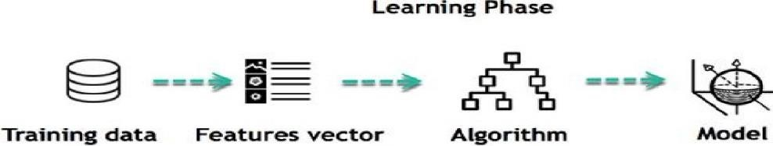
Machine learning is the brain where all the learning takes place. The way the machine learns is similar to the human being. Humans learn from experience. The more we know, the more easily we can predict. By analogy, when we face an unknown situation, the likelihood of success is lower than the known situation. Machines are trained the same. To make an accurate prediction, the machine sees an example. When we give the machine a similar example, it can figure out the outcome. However, like a human, if its feed a previously unseen example, the machine has difficulties to predict.

The core objective of machine learning is the learning and inference. First of all, the machine learns throughthe discovery of patterns. This discovery is made thanks to the data. One crucial part of the data scientist is to choose carefully which data to provide to the machine. The list of attributes used to solve a problem is called a feature vector. You can think of a feature vector as a subset of data that is used to tackle a problem.

The machine uses some fancy algorithms to simplify the reality and transform this discovery into a
model. Therefore, the learning stage is used to describe the data and summarize it in to a model.

For instance, the machine is trying to understand the relationship between the wage of an individual and the likelihood to go to a fancy restaurant. It turns out the machine finds a positive relationship between wage and going to a high-end restaurant: This is the model

Applications of Machine Learning:

Augmentation:

    - Machine learning, which assists humans with their day-to-day tasks, personally or commercially without having complete control of the output. Such machine learning is used in different ways such as Virtual Assistant, Data analysis, software solutions. The
primaryuser is to reduce errors due to human bias.

Automation:

    - Machine learning, which works entirely autonomously in any field without the need for any human intervention. For example, robots performing the essential process steps in manufacturing plants.

Finance Industry

    - Machine learning is growing in popularity in the finance industry. Banks are mainly using ML to find patterns inside the data but also to prevent fraud.

Government organization

    - The government makes use of ML to manage public safety and utilities. Take the example of China with the massive face recognition. The government uses Artificial intelligence to prevent jaywalker.

MACHINE LEARNING METHODS
Machine learning classifiers fall into three primary categories.

Supervised machine learning
Supervised Learning, also known as supervised machine learning, is defined by its use of labeled datasets to train algorithms that to classify data or predict outcomes accurately. As input data is fed into the model, it adjusts its weights until the model has been fitted appropriately. This occurs as part of the cross validation process to ensure that the model avoids overfitting or underfitting. Supervised learning helps organizations solve for a variety of real-world problems at scale, such as classifying spam in a separate folder from your inbox. Some methods used in supervised learning include neural networks, naïve bayes, linear regression, logistic regression, random forest, support vector machine (SVM), and more.

Unsupervised machine learning

Unsupervised Learning, also known as unsupervised machine learning, uses machine learning algorithms to analyze and cluster unlabeled datasets. These algorithms discover hidden patterns or data groupings without the need for human intervention. Its ability to discover similarities and differences in information make it the ideal solution for exploratory data analysis, crossselling strategies, customer segmentation, image and pattern recognition. It’s also used to reduce the number of features in a model through the process of dimensionality reduction; principal component analysis (PCA) and singular value decomposition (SVD) are two common approaches for this. Other algorithms used in unsupervised learning include neural networks, k-means clustering, probabilistic clustering methods, and more.

Semi-supervised learning

Semi-supervised learning offers a happy medium between supervised and unsupervised learning. During training, it uses a smaller labeled data set to guide classification and feature extraction from a larger, unlabeled data set. Semi-supervised learning can solve the problem of having not enough labeled data (or not being able to afford to label enough data) to train a supervised learning algorithm or a deep neural network. A neural network that only has two or three layers is just a basic neural network.

5.EXISTING AND PROPOSED SYSTEM

EXISTING SYSTEM

After the recent ups and downs in the value of crypto currencies, Bitcoin is now more frequently seen as a potential investment. Due to its extreme volatility, accurate forecasts are necessary to guide investment choices. Despite the fact that previous studies have used

Few studies have concentrated on the viability of applying various modelling approaches to samples with various data formats and dimensional attributes when using machine learning for more precise Bitcoin price prediction. We initially categorise Bitcoin price by daily price and high-frequency pricing in order to forecast Bitcoin price at various frequencies using machine learning techniques. For the purpose of predicting the daily price of Bitcoin, a collection of high-dimension features, such as property and network, trade and market, attention, and the current price of gold, are employed.

Crypto-currency, a technology supported virtual currency, is not issued by Government agency. It has highly volatile market price. The market capitalization of publicly traded crypto-currency is currently above $230 billion. The digital currency came to existence with the introduction of Bitcoin in 2013. The purpose of the regression is to predict, for example, predicting the weather temperature tomorrow, predicting the trend of stocks. The reason why the return can be predicted is because he has used the historical data to understand the "routines" and then use this routine to predict future results. A linear relationship can only exist for 2 variables (two-dimensional planes).

Algorithm:Linear Regression Strength:Easy to implement and interpret Weakness:Less accuracy

PROPOSED SYSTEM

In comparison to more complex machine learning algorithms, statistical techniques like Logistic Regression and Linear Discriminant Analysis for daily Bitcoin price prediction using high-dimensional features reach an accuracy of 66%. Compared to daily price benchmark results

With the maximum accuracy of the statistical techniques and machine learning algorithms of 66% and 65.3%, respectively, we get a higher performance in prediction. With an accuracy of 67.2%, machine learning models like Long Short-Term Memory for Bitcoin 5-minute interval price prediction outperform statistical approaches. Considered a pilot study of the significance of the sample dimension in machine learning methods, our examination into Bitcoin price prediction.

This project aim is revealing the usefulness of traditional arima modeling for predicting the future value of bitcoin by analyzing the price time series in a 3-years period.
Algorithm :AutoRegressive Integrated Moving Average.
Advantage:It helps to understand the past data and would be helpful for future predictions

MODULE DESCRIPTION

DATA SET PREPARATION:

Data used in this paper is a set of records. This step is concerned with selecting the subset of all available data that you will be working with. ML problems start with data preferably, lots of data(examples or observations) for which you already know the target answer. Data for which you already know the target answer is called labelled data.

PREPROCESSING DATASET:

- Organize your selected data by formatting, cleaning and sampling from it.
- Three common data pre-processing steps are:
- Formatting
- Cleaning
- Sampling
Formatting: The data you have selected may not be in a format that is suitable for you to work with. The data may be in a relational database and you would like it in a flat file, or the data may be in a proprietary file format and you would like it in a relational database or a text file.
Cleaning: Cleaning data is the removal or fixing of missing data. There may be data instances that are incomplete and do not carry the data you believe you need to address the problem. These instances may need to be removed. Additionally, there may be sensitive information in some of the attributes and these attributes may need to be anonym zed or removed from the data entirely. Sampling: There may be far more selected data available than you need to work with. More data can result in much longer running times for algorithms and larger computational and memory requirements. You can take a smaller representative sample of the selected.

After doing the exploratory data analytics, the process calls for proper preprocessing, including removing the missing values and stop words, deleting the irrelevant attributes that can be observed from the correlation heat-map, and finally removing the extra space. Now, the dataset is ideal for transforming into categorical encoding to achieve a feature vector. This feature
vector would then be the final and transformed input to the classifiers. For the first phase of this paper, we have collected Bitcoin values from four different
databases: Coinmarketcap, Bitstamp, Coinbase, and Blockchain Info. We gathered Bitcoin historical and real time price data using their publicly available API. From Coinmarketcap and Blockchain Info, we have collected 11 key features (see Table 1) relevant to the Bitcoin values for our research with their real-time feature (e.g. created date). In addition, from Bitstamp database, we also acquired 10 more transaction based different level of details which are returned by API call for the pricing data (see Table 2). This dataset was gathered an

interval length of every one-minute and it continued the data collection process. From Coinbase API we collected bitcoin real-time data in order to predict the fluctuation of the bitcoin price with others collected dataset. We collected bitcoin price data by building an automated web scraper which is real-time data pulled from Coinbase API over the course of weeks or months or years depending on program continuation. All these key features are connected with bitcoin network and important to real-time observation of moving prices.

The complete project has been implemented using Python programming language and various libraries available in Python. These libraries are:
- Tkinter
- Tensorflow
- numPy
- Pandas
- OS

Tkinter:
Python has many options for developing Graphical User Interface. From all methods, tkinter is most used method..Python with tkinter will be very useful to create the GUI applications. Using tkinter creating GUI is made easy . Tkinter calls will be translated into Tcl commands which are used in embedded interpreter and it made possible to use python and commands in one application. Tkinter provides various controls, such as labels, buttons and text boxes used in a GUI . Controls are also called widgets. Tkinter commonly comes bundled with Python, using Tk and is Python's standard GUI framework. It is open-source and available under the Python License.

TensorFlow:
TensorFlow is an open source AI library which is used for creating models . TensorFlow is machine learning framework that was created by Google to design, build, and train deep learning models. TensorFlow library can be used to numerical computations, which are not so special, but these computations are done with data flow graphs. In these graphs, nodes represent mathematical operations, while the data is represented by edges, which are multidimensional data arrays that are communicated between the edges. The name
―TensorFlow is derived from the operations which neural networks perform on multidimensional data arrays.

OS:
The OS python provides functions for the interaction with the operating system. OS is part of Python's standard utility modules. This module provides a portable way of using operating system dependent functionality. The os and os.path modules has many functions to interact with the file system. TensorFlow allows developers to create dataflow graphs— structures that describe how data moves through a graph and series of processing nodes. Each node represents one of the operations. NumPy:
NumPy, which stands for Numerical Python, is a library consisting of multidimensional array objects and a collection of routines for processing those arrays. Using NumPy, mathematical and logical operations on arrays can be performed. This tutorial explains the basics of NumPy such as its architecture and environment. It also discusses the various array functions, types of indexing, etc. An introduction to Matplotlib is also provided. Pandas:
Pandas is an open source Python package that is most widely used for data science/data analysis and machine learning tasks. It is built on top of another package named Numpy, which provides support for multi-dimensional arrays. Training Dataset: Most approaches that search through training data for empirical relationships tend to overfit the data, meaning that they can identify and exploit apparent relationships in the training data that do not hold in general. A training dataset is a dataset of examples used for learning, that is to fit the parameters. Testing Dataset: A test dataset is a dataset that is independent of the training dataset, but that follows the same probability distribution as the training dataset. If a model fit to the training dataset also fits the test dataset well, minimal overfitting has taken place A test set is therefore a set of examples used
only to assess the performance that is generalization of fully specified classifier.

7. UML DESIGN DIAGRAM

UML is the international standard notation for object-oriented analysis and design. The object management group defines it. The heart of object-oriented problem solving is the construction of models. The model abstracts the essential details of the underlined problem from its usually complicated real world. Several modelling tools are wrapped under the heading of unified modelling language. It is a language for visualizing, specifying, constructing documents. The Unified Modeling Language (UML) is used to specify, visualize, modify, construct and document the artifacts of an object-oriented software intensive system under development. UML offers a standard way to visualize a system's architectural blueprints, including elements such as:
- Actors
- Business processes
- Logical components
- Activities
- Programming language statements
- Database schemas, and
- Reusable software components

USE CASE DIAGRAM:

A use case diagram in the Unified Modeling Language (UML) is a type of behavioraldiagram defined by and created from a Use-case analysis. Its purpose is to present a graphical overview of the functionality provided by a system in terms of actors, their goals (represented as use cases), and any dependencies between those use cases. The main purpose of a use case diagram is to show what system functions are performed for which actor. Roles of the actors in the system can be depicted.

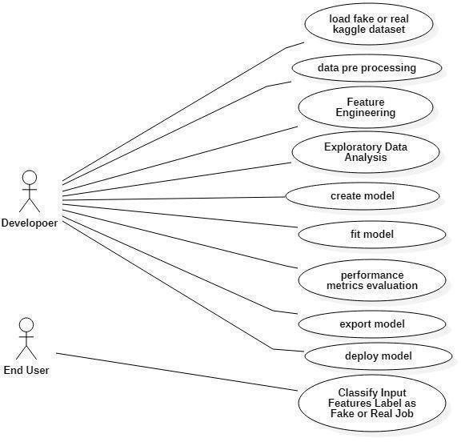

FIGURE 7.1:USE CASE DIAGRAM

  - SEQUENCE DIAGRAM:
Sequence Diagrams Represent the objects participating the interaction horizontally and time vertically. A Use Case is a kind of behavioral classifier that represents a declaration of an offered behavior. Each use case specifies some behavior, possibly including variants that the subject can perform in collaboration with one or more actors. Use cases define the offered behavior of the subject without reference to its internal structure. These behaviors, involving interactions between the actor and the subject, may result in changes to the state of the subject and communications with its environment.
Sequence Diagrams Represent the objects participating the interaction horizontally and time vertically. A Use Case is a kind of behavioral classifier that represents a declaration of an offered behavior. Each use case specifies some behavior, possibly including variants that the subject can perform in collaboration with one or more actors. Use cases define the offered behavior of the subject without reference to its internal structure. These behaviors, involving interactions between the actor and the subject, may result in changes to the state of the subject and communications with its environment

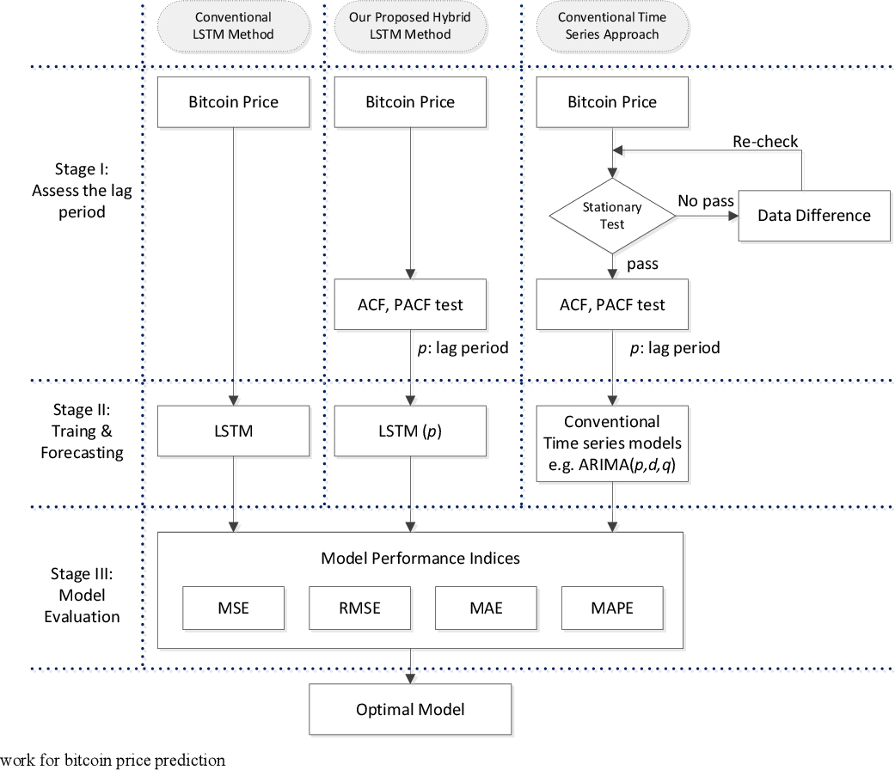

FIGURE 7.2 : SEQUENCE DIAGRAM

7.3 ACTIVITY DIAGRAM:

Workflows comprising sequential activities and actions with provision for choice, iteration, and concurrency are graphically represented in activity diagrams. Activity diagrams may be used to depict the operational and business processes of system components in the Unified Modeling Language. An activity diagram demonstrates the total control flow.
  - of components in a system. An activitydiagram shows the overall flow of control.

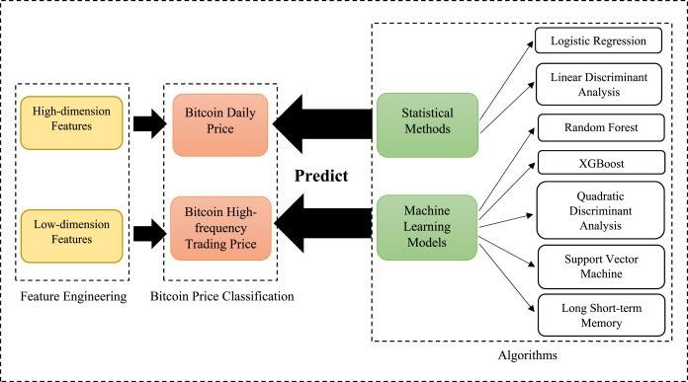

FIGURE 7.3: ACTIVITY DIAGRAM

  - CLASS DIAGRAM:

The class diagram is the main building block of object-oriented modeling. It is used for general conceptual modeling of the systematic of the application, and for detailed modeling translating the models into programming code. Class diagrams can also be used for data modeling.[1] The classes in a class diagram represent both the main elements, interactions in the application, and the classes to be programmed. In the diagram, classes are represented with boxes that contain three compartments: The top compartment contains the name of the class. It is printed in bold and centered, and the first letter is capitalized. The middle compartment contains the attributes of the class. They are left-aligned and thefirst letter is lowercase. The bottom compartment contains the operations the class can execute. They are also left-aligned and the first letter is lowercase

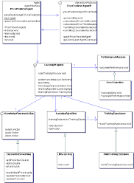

FIGURE 7.4:CLASS DIAGRAM

  - DEPLOYMENT DIAGRAM:

Deployment diagrams are graphical representations of Workflows of stepwise activities and actions with support for choice, iteration and concurrency. In the Unified Modeling Language, activity diagrams can be used to describe the business and operational step-by-step workflows of components in a system. An activity diagram shows the overall flow of control.

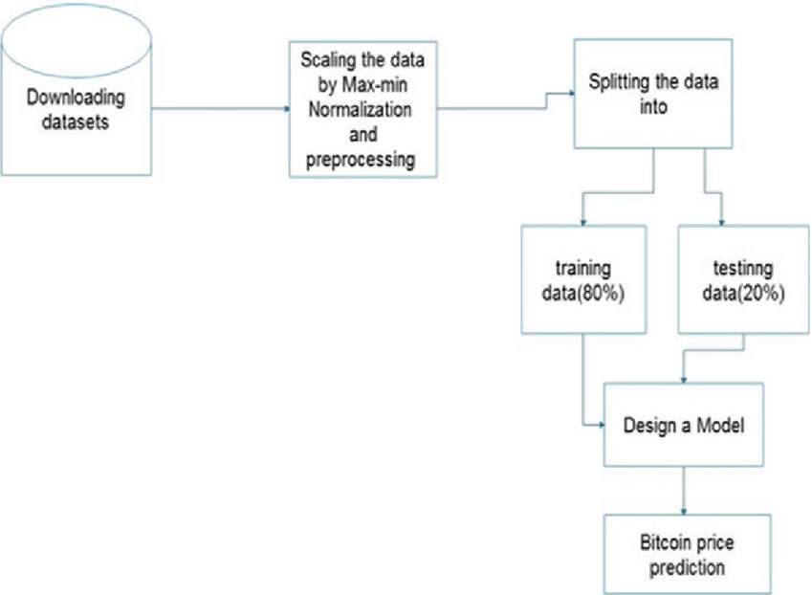

FIGURE 7.5 DEPLOYMENT DIAGRAM

8. CONCLUSION

In this project, we have investigated bitcoin price prediction by using an ARIMA model. Towards this end, at first we have preprocessed data to make it stationary, and then, have searched over feasible (p; q; d) tuples for finding the ARIMA model which minimizes the MSE of prediction.
Our results indicate that the bitcoin price prediction using its closing price history could results in large MSE values due to bitcoin‘s price vulnerability to high jumps and fall-downs. On the other hand, the results confirm that the ARIMA model could be still used for price prediction in sub-periods of the timespan, i.e. by dividing the timespan to several time-spans over which, dataset has a unique trend. We have achieved an accuracy of Results with 95% confidence interval.

REFERENCES

- Wikipedia. (2018) The world‘s billionaires. [Online]. Available: https://en.wikipedia.org

- M. Amjad and D. Shah, ―Trading bitcoin and online time series prediction,‖ in NIPS 2020Time Series Workshop, 2021, pp. 1–15.
- M. Amjad and D. Shah, "Trading Bitcoin and Online Time Series Prediction," in NIPS 2019Time SeriesWorkshop, 2017.
- D. Garcia and F. Schweitzer, "Social signals and algorithmic trading of Bitcoin," RoyalSociety OpenScience, vol. 2, no. 9, 2018.
- R. Chen and M. Lazer, "Sentiment Analysis of Twitter Feeds for the Prediction of StockMarketMovement," Stanford Computer Science, no. 229, 2020, p. 15.
- A. Go, L. Huang and R. Bhayani, "Twitter Sentiment Classification using Distant Supervision,"StanfordComputer Science, 2019.
- B. Pang, L. Lee and S. Vaithyanathan, "Thumbs up: sentiment classification using machine learning techniques," in ACL-02 conference on Empirical methods in natural language processing,Philadelphia, PA, USA,2021.
- M. Dixon, D. Klabjan and J. H. Bang, "Classification-based financial markets prediction usingdeep neuralnetworks," ArXiv, 2018.
- S. McNally, J. Roche and S. Caton, "Predicting the price of Bitcoin using machine learning," in 26thEuromicro International Conference on Parallel, Distributed and Network-based Processing (PDP), 2018.
[10]M. Daniela and A. BUTOI, "Data mining on Romanian stock market using neural networks forpriceprediction," Informatica Economica, vol. 17, no. 3, 2020.
- D. Shah and K. Zhang, "Bayesian regression and Bitcoin," in 52nd Annual AllertonConference onCommunication, Control, and Computing (Allerton), 2019.
- H. Jang and J. Lee, "An Empirical Study on Modelling and Prediction of Bitcoin Prices with BayesianNeural Networks based on Blockchain Information," in IEEE Early Access Articles, 2019.

